**DIP-Lab mini project**

**Name:** Shweta Ramakant Padamwar.

**Class:** TyBtech_Entc(A)

**Batch:** DIP_II

**Roll No:** 3148

**1.Title:** Edge detection using Difference of Gaussian(DoG) algorithm.

**2.Theory in brief:**

It produce the unwanted side effect of increasing random noise in the image. Because it removes high-frequency spatial detail that can include random noise, the **difference of gaussians** algorithm is useful for enhancing edges in noisy digital images. This interactive tutorial explores application of the difference of gaussians algorithm to images captured in the microscope. The DOG filter is similar to the [LOG](http://www.roborealm.com/help/LOG.php) and [DOB](http://www.roborealm.com/help/DOB.php) filters in that it is a two stage edge detection process.The final image is then calculated by replacing each pixel with the difference between the two blurred images and detecting when the values cross zero, i.e. negative becomes positive and vice versa. The resulting zero crossings will be focused at edges or areas of pixels that have some variation in their surrounding neighborhood.

The **Blurred Specimen** windows display the images that result from applying a **Gaussian blur** to the specimen image. The strength of the blur effect can be varied by using the **s(1)** and **s(2)** sliders, which will affect the appearance of the images in the left and center windows, respectively. Visitors should note that the value of the **s(1)** slider must be less than the value of the **s(2)** slider, and the tutorial will ensure this condition by automatically limiting the range of motion of the sliders. The **Difference Image (1) - (2)** window displays the image that results from subtracting the image appearing in the center window (**Blurred Specimen (2)**) from the image contained in the left-hand window (**Blurred Specimen (1)**). Visitors should explore how adjusting the slider combination affects the appearance of the blurred images and the difference image.

Difference of gaussians is a grayscale image enhancement algorithm that involves the subtraction of one blurred version of an original grayscale image from another, less blurred version of the original. The blurred images are obtained by convolving the original grayscale image with Gaussian kernels having differing standard deviations. Blurring an image using a Gaussian kernel suppresses only high-frequency spatial information. Subtracting one image from the other preserves spatial information that lies between the range of frequencies that are preserved in the two blurred images. Thus, the difference of gaussians is equivalent to a **band-pass filter** that discards all but a handful of spatial frequencies that are present in the original grayscale image. In its operation, the difference of gaussians algorithm is believed to mimic how neural processing in the retina of the eye extracts details from images destined for transmission to the brain.

The plot of a cross section of two Gaussian curves with different standard deviations and their difference is illustrated in Figure 1. Note how the difference curve closely resembles that of the **Laplacian**, another commonly used edge enhancement algorithm.

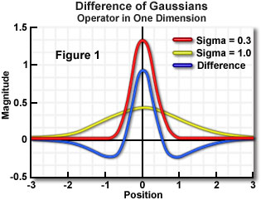

As an image enhancement algorithm, the difference of gaussians can be utilized to increase the visibility of edges and other detail present in a digital image. A wide variety of alternative edge sharpening filters operate by enhancing high frequency detail, but because random noise also has a high spatial frequency, many of these sharpening filters tend to enhance noise, an undesirable artifact. The difference of gaussians algorithm removes high frequency detail that often includes random noise, rendering this approach one of the most suitable for processing images with a high degree of noise. A major drawback to application of the difference of gaussians algorithm is an inherent reduction in overall image contrast produced by the operation.

**3.Algorithm.**

1. Start.

2. Read the input image.

3. Display the original grayscale image.

4. By using the pixelCount(i.e mark the pixel as edge pixel) and grayLevels plot the histogram of original image.

5. Blur the image using gaussian filter by computing the sigma values.

6. And find out the difference of gaussian then convoled it w.r.t original image by restricted the grayImage as(:,:,1).

7. Then Display the DoG filtered image.

8. Repeat step 4 and Display the histogram of DoG filtered image.

9. Stop.

**4.Program with comments.**

clc; %Clear the command window

close all; %Close all figures

clear all; %Erase all existing variables

figure(1);

grayImage = imread('building.jpg');

% Get the dimensions of the image.

% numberOfColorBands should be = 1.

[rows, columns, numberOfColorBands] = size(grayImage);

% Display the original gray scale image.

subplot(2, 2, 1);

imshow(grayImage, []);

title('Original Grayscale Image');

% Enlarge figure to full screen.

%set(gcf, 'units','normalized','outerposition',[0 0 1 1]);

% Give a name to the title bar.

%set(gcf,'name','Demo by ImageAnalyst','numbertitle','off');

% Let's compute and display the histogram.

[pixelCount, grayLevels] = imhist(grayImage);

subplot(2, 2, 2);

bar(pixelCount);

grid on;

title('Histogram of Original Image');

xlim([0 grayLevels(end)]); % Scale x axis manually.

gaussian1 = fspecial('Gaussian', 21, 15);

gaussian2 = fspecial('Gaussian', 21, 20);

dog = gaussian1 - gaussian2; %Calculate the difference of gaussian.

%Convoled the gaussian (blurred) image with original grayscale image.

dogFilterImage = conv2(double(grayImage(:,:,1)), dog, 'same');

subplot(2, 2, 3);

imshow(dogFilterImage, []);

title('DoG Filtered Image');

% Let's compute and display the histogram.

[pixelCount, grayLevels] = hist(dogFilterImage(:));

subplot(2, 2, 4);

bar(grayLevels, pixelCount);

grid on;

title('Histogram of DoG Filtered Image');

**5.Screenshots of 2 images and result of your**

**program.**

* **Screenshots of 2 images**

**1.**building 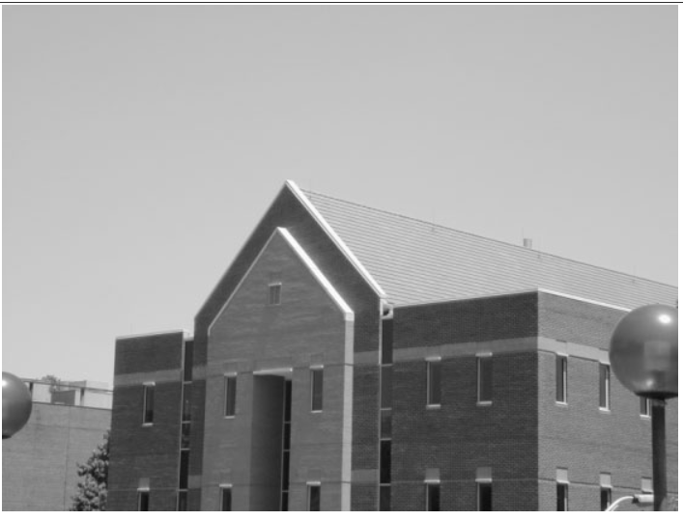

**2.**brain

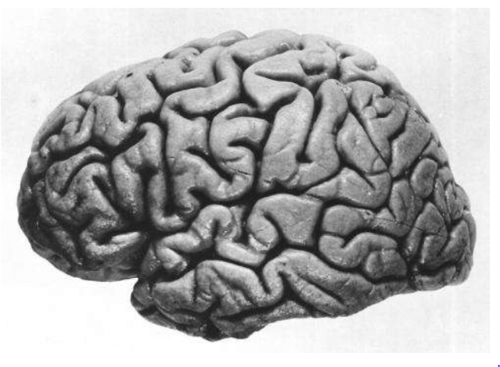

* **Code Output.**

**1.**building.jpg

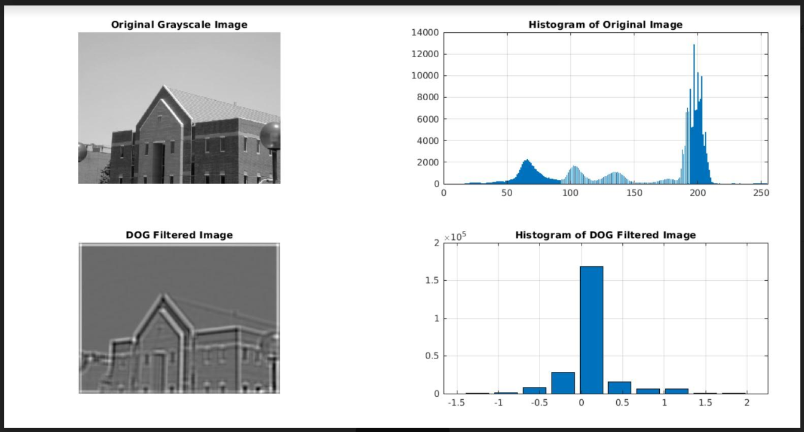

**2.**brain.jpg

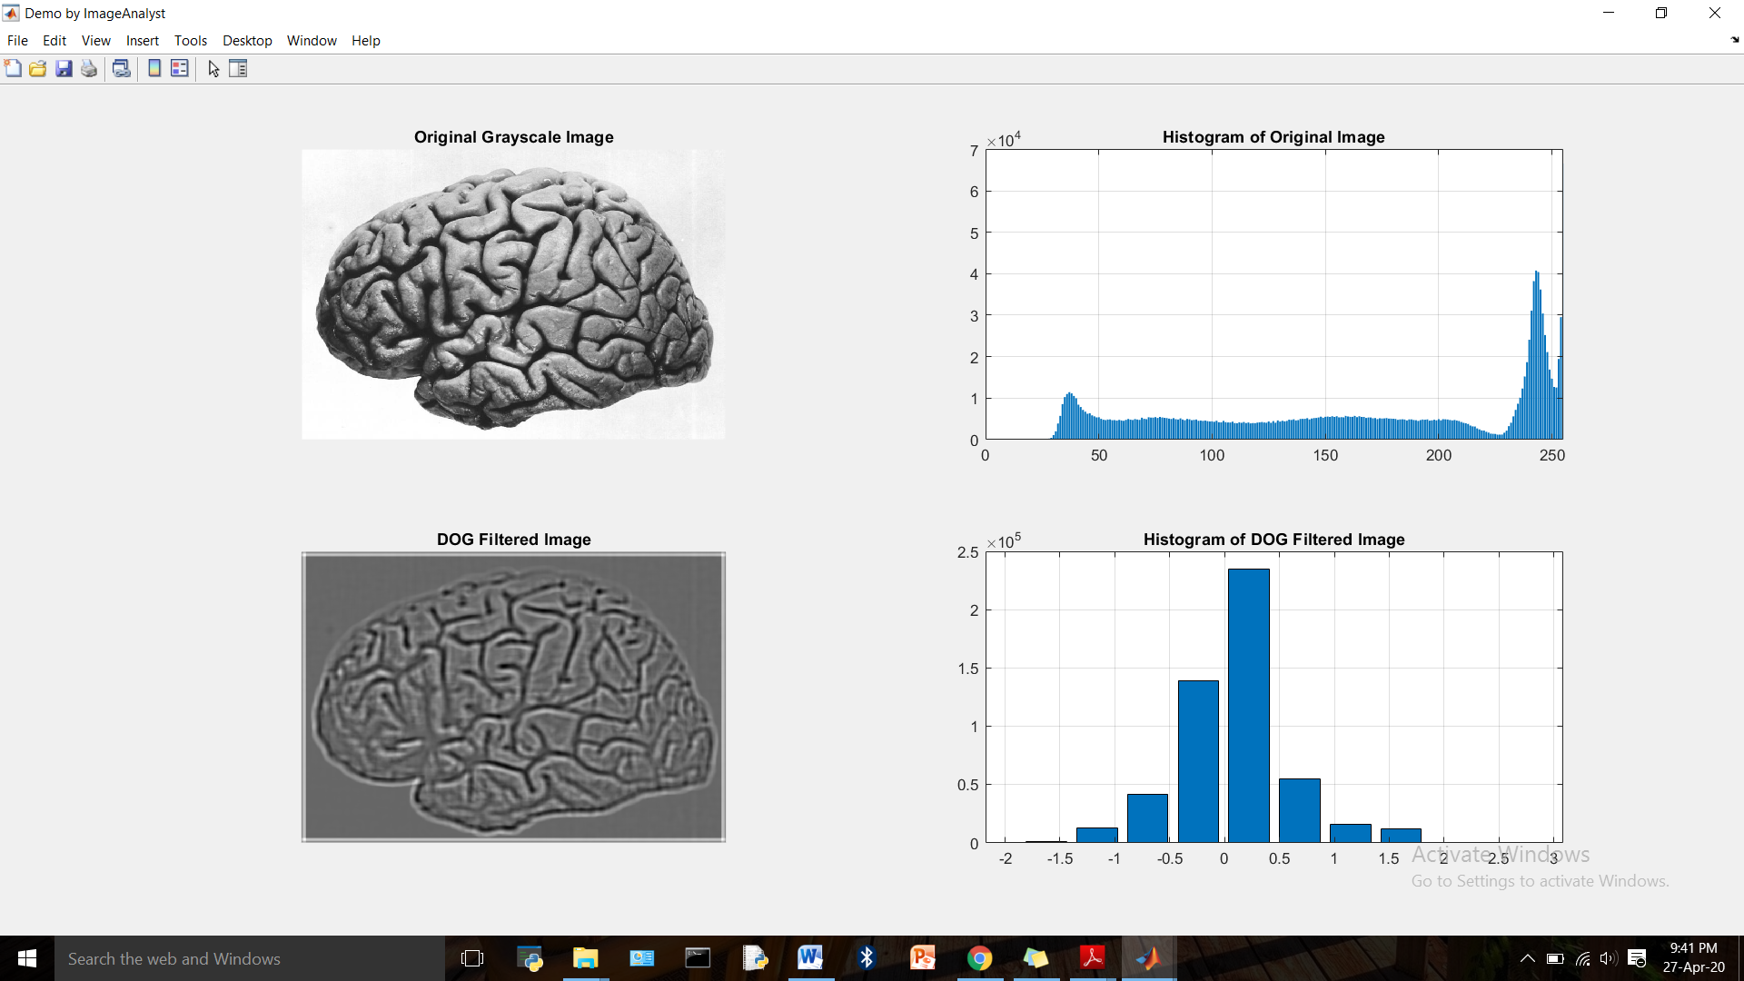

**6.Conclusion:**

The Difference of Gaussian module is a filter it identifies edges.

The DOG performs edge detection by performing a Gaussian blur on an image at a specified theta values(also known as sigma or standard deviation). The resulting image is a blurred version of the source image. By applying the convolution of a blurred (i.e gaussian) image w.r.t original grayscale image. Then finally the resulting image is a filtered edge detecting image of a original image by using DoG edge detection algo.